Problem – Solution Fit
ShopEZ — MERN Stack E-commerce Application

Phase: Project Design Phase
TEAM ID : SWUID2026207177
Classification: Project Documentation — For Academic Submission
Problem – Solution Fit
1
. Introduction
This document formally validates the ^{Problem–Solution Fit} of the ShopEZ platform. Fit is achieved when a proposed solution demonstrably and efficiently addresses the core pain points of target customer segments while delivering measurable gains that differentiate it from existing market alternatives.
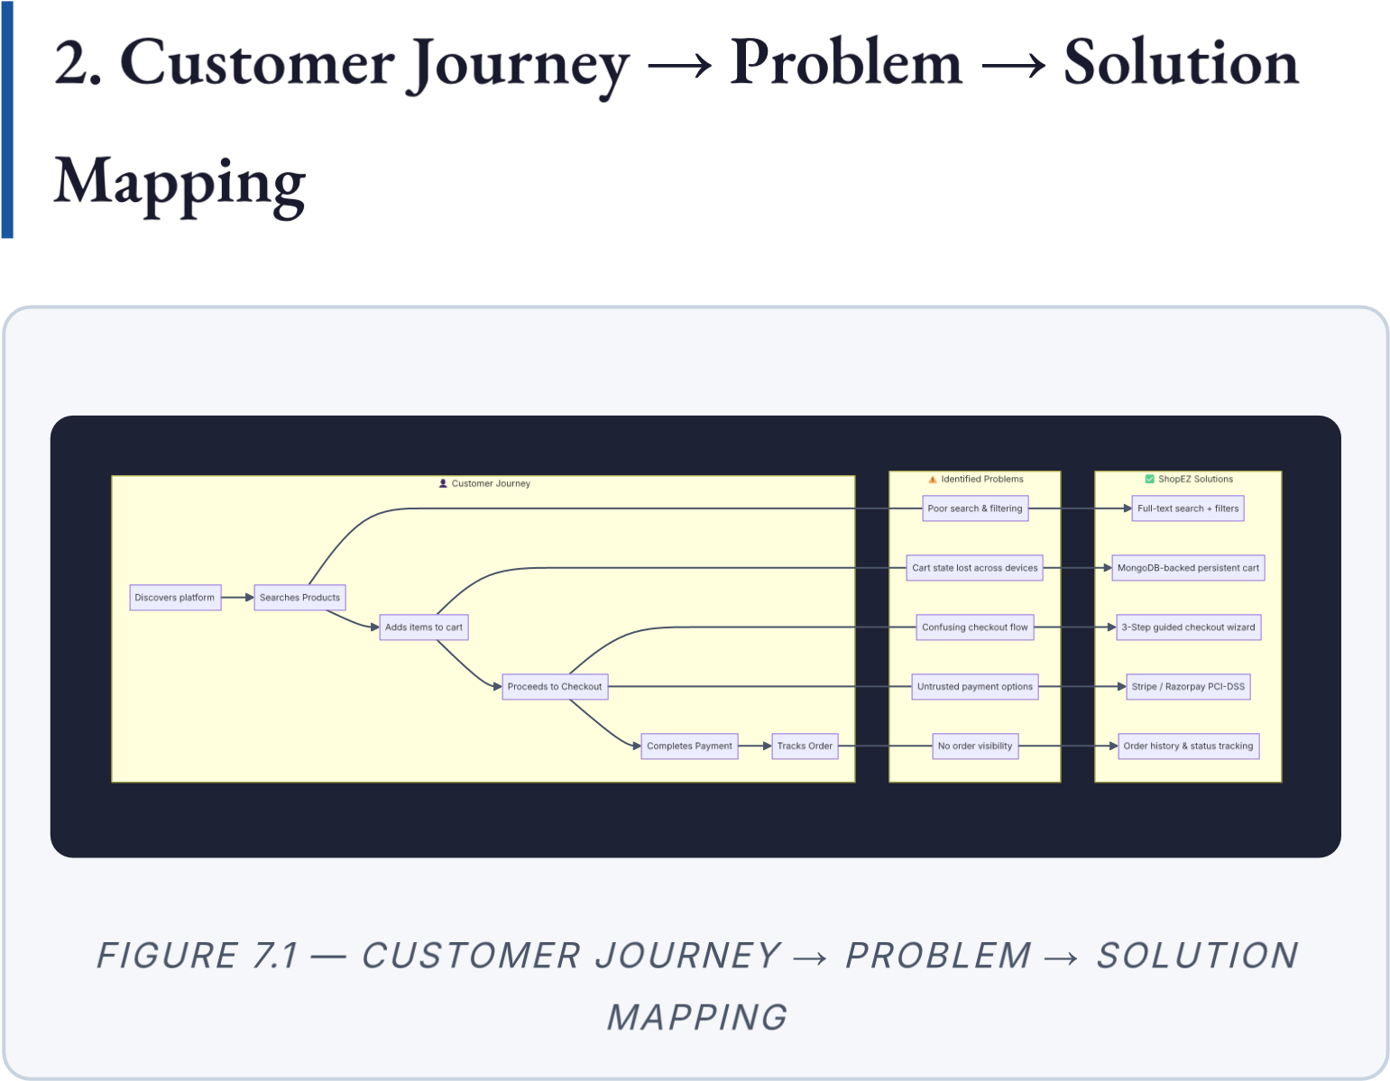
3. Competitive Analysis
Criterion | Shopify | WooCommerce | Custom  PHP | ShopEZ  (MERN)
Customisability | Limited | Moderate | High | ✅ Full Control
SPA  Performance | ❌ No  (SSR) | ❌ No (SSR) | ❌ No | ✅ React  SPA
Monthly Cost | ₹2,000–  ₹20,000 | ₹500–₹5,000 | Variable | ✅ Low  (Free  Tiers)
Cross-Device  Cart | ✅ Yes | ✅ Yes | ❌ No | ✅ Yes (MongoDB)
Admin  Dashboard | ✅  Basic | ✅ Pluginbased | ❌  Manual | ✅ Custom  Analytics
Payment  Gateways | Limited | Multiple  (plugins) | Manual | ✅ Stripe +  Razorpay
Image CDN | ✅ Yes | ❌ No | ❌ No | ✅  Cloudinary
Developer  Ownership | ❌  Lock-in | Partial | ✅ Yes | ✅ Full  Ownership
Scalability | Limited by plan | Limited by hosting | Complex | ✅  Stateless  API
4. Fit Validation Summary
Problem | Solution Provided | Fit?
Cart state lost across sessions | MongoDB-persisted cart linked to user ID | ✅  Yes
Poor search & discovery | Full-text search + multi-criteria filter  API | ✅  Yes
Confusing checkout | 3-step guided wizard (Address →  Method → Payment) | ✅  Yes
Untrusted payment process | Stripe / Razorpay PCI-DSS compliant gateway | ✅  Yes
Slow page loads | React SPA + Cloudinary CDN | ✅  Yes
No admin analytics | Custom Admin Dashboard with revenue charts | ✅  Yes
Manual image hosting | Cloudinary auto-optimise & CDN delivery | ✅  Yes
Overall Assessment: ✅ Validated — All identified problems have documented and implemented solution counterparts. Problem– Solution Fit is confirmed for both primary customer segments.

ShopEZ MERN E-commerce Application · Project Design Phase · Problem – Solution Fit

